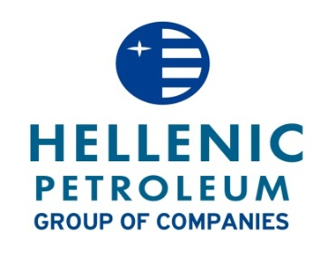
RESOLUTIONS OF THE EXTRAORDINARY GENERAL MEETING
OF 2nd SEPTEMBER 2013

“Hellenic Petroleum S.A.” announces that at the Extraordinary General Meeting of the Shareholders of the company, which was held on 2.9.2013, at 10.00 at the Company's premises at Aspropyrgos (17th km of Athens - Corinth National Road), 107 shareholders, representing 246.033.555 shares and voting rights, out of a total of 305.635.185 shares, i.e. 80,50% of the paid up share capital, attended or were duly represented at the meeting.

The Extraordinary General Meeting decided as follows on the following items of the agenda:

1st Item: Approval of the sale of “HELLENIC PETROLEUM SA” participation in «DESFA S.A.”

The General Meeting approved (100 % of the present share capital) the transfer of the participation of “HELLENIC PETROLEUM SA” in the share capital of «DESFA S.A.” to SOCAR, or any other legal entity, member of the SOCAR Group that the buyer will suggest, against a consideration of €212.1m and confirmed the authorization granted to the Chief Executive Officer and Managers of the Company by virtue of the resolution of the Board of Directors No. 1203/1/2.8.2013 to execute the Sales and Purchase Agreement (SPA) as well as any other document that will be required to complete the above sale process. Furthermore, the General Meeting approved, as a necessary step for the completion of the above transfer of shares, the share capital decrease of DEPA S.A. and the transfer of the 35% of DESFA S.A. shares to Hellenic Petroleum SA as in kind return of capital. Such share capital decrease will be resolved by the General Meeting of Shareholders of DEPA S.A., which will take place after the execution of the aforementioned SPA.

Number of shares accounting for valid votes: 246.033.555
Percentage of the share capital: 80,50%
Total number of valid votes: 246.033.555
Number of votes in favour: 246.033.555 against: 0 abstained: 0

2nd Item: Approval of the change in the composition of the Audit Committee in accordance with the provisions of Law 3693/2008.

The General Meeting decided by majority (99,997% of the present share capital) the ratification of the decision No. 1202/25.7.2013 of the BoD regarding the reshuffling of the Audit Committee, according to Law 3693/2008, where Mr. Ioannis Sergopoulos, Mr. Vasileios Nikoletopoulos and Mr. Spyridon Pantelias were appointed as Members of the abovementioned Committee.

Number of shares accounting for valid votes: 246.033.555
Percentage of the share capital: 80,50%
Total number of valid votes: 246.033.555
Number of votes in favour: 246.027.413 against: 6.142 abstained: 0

MAROUSI 2.09.2013
THE BOARD OF DIRECTORS

